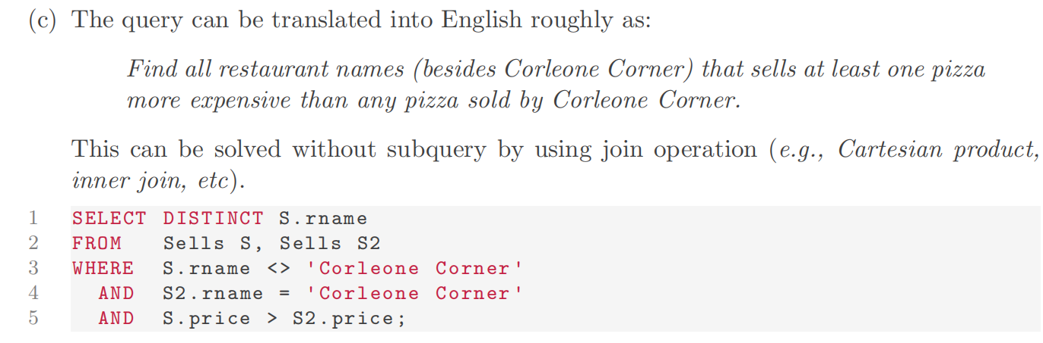

Because the **cross product contains every possible combinations of S and S2** => only have to do ‘S.price > S2.price’ and find there is one (If this dose not return anything, then it means for every S2, the price is bigger than S) => Then the restaurant can be selected

1. Empty Set JOIN R = Empty Set

